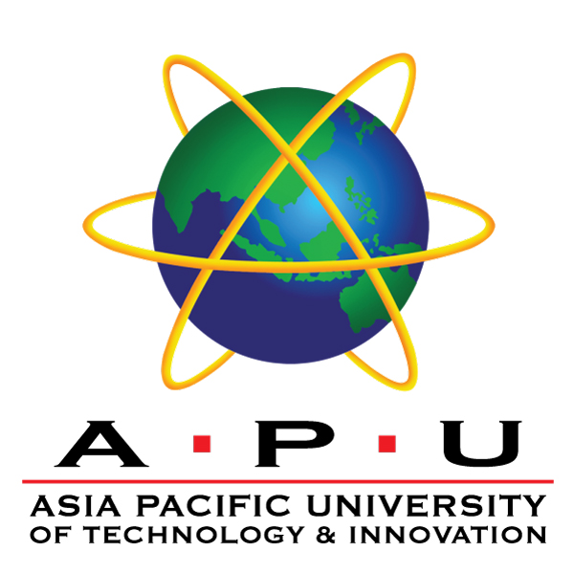

**INDIVIDUAL REFLECTION.**

**TECHNOLOGY PARK MALAYSIA.**

**Co-Curricular 2**

**APD1F2209CS(CYB).**

**GROUP NUMBER: 11.**

**HAND-OUT DATE: WEEK 2.**

**HAND-IN DATE: WEEK 14.**

|  |  |
| --- | --- |
| ***TP_NUMBER:*** | ***STUDENT NAME:*** |
| *TP071012* | *ABDULRAHMAN GAMIL MOHAMMED AHMED* |

Contents

**Skills relevant to my future**  3

**Skills learnt during the project** 4

**Skills relevant to my future:**

**Teamwork.**

Successful implementation of any task requires unbridled cooperation among teams involved - this includes pulling off an impeccable event operation. We keep ourselves well-connected throughout the weaving process by continuously trusting each other which ensures smooth execution at every turn development phase. My vision for future prospects is primarily grounded towards cyber security engineering, and collaborative effort remains fundamental within this field too - allowing us (as experts) to protect business stakeholders more comprehensively thereby ensuring overall peace of mind for clients dealing with such companies or institutions.

**Time management and organizational skills.**

The ability to manage time and maintain a highly organized workflow is essential for future career success. It involves setting practical goals, improvising scheduling techniques, and using tools such as online calendars and accessible mobile apps. Organizational capabilities are also key, such as taking care of crucial documents electronically/physically and labelling documentations effectively. These techniques form critical pillars for future career success through enhanced focus at work and efficient management practices that maximize output delivery quality.

**Skills learnt during the project:**

**Communication skill.**

The art of effective communication involves delivering ideas or messages in clear and concise ways that can be easily understood by others. This incorporates grasping concepts or instructions before carrying out necessary actions. Communication proficiency includes verbal as well as nonverbal cues while active listening plays a significant role too. Participating in the Museum event has equipped me with helpful tips on how to communicate about our trip successfully within the community circle. While explaining Malaysian cultural aspects to students, we must ensure kindness throughout the process. Furthermore, coordinating during rush hour heightened my senses toward understanding how crucial it is to use body language or gestures effectively.

**having trust in other people.**

Trusting your teammates is key to creating synergy within a group setting that allows members to operate smoothly without fear or trepidation. Growing and experience have made the speaker more willing to trust others around them as confidants and equals working as part of a team. In life itself, trust is paramount; only its positive element yields fruitfulness in what we undertake as individuals or groups, and damaging forms of trust can threaten or ruin any endeavors sought-after via teamwork. To create a positive working environment where social skill-building opportunities abound, communication channels flow without hindrance, and quality speed measurements are surging upward due to their united efforts on trusting one another.